CHAPTER TWO

2.0. LITERATURE REVIEW

2.1. INTRODUCTION TO LITERATURE REVIEW
This literature review presents a critical analysis of existing student fee payment solutions, examining the methodologies, technologies, and outcomes reported in academic and industry sources (Kumar & Sharma, 2020). By comparing these systems, the review aims to uncover patterns, best practices, and recurring challenges. Particular attention is given to system architecture, payment processing models, user experience design, data management, and institutional adaptability (Nwachukwu & Okeke, 2020). The evolution of student fee payment systems has been marked by diverse implementations across educational institutions, each designed to address the unique financial, administrative, and technological contexts in which they operate (Aladi, 2019). From basic manual processes to advanced digital platforms, these systems reflect varying degrees of efficiency, accessibility, security, and integration with broader institutional frameworks (Mensah & Owusu, 2022) Through this comparative lens, the review identifies both strengths and limitations in current approaches, thereby laying the groundwork for the design of an improved system tailored to specific operational needs and user requirements (Ahmed & Yusuf, 2020).
We have reviewed three payment systems used primarily by university students for payments of different kinds of fees in the university. Which aims at easing the burdens of joining long queues in banks, damage or loss of receipts and many other inconveniences students go through to make payments manually at banks and also reduce the pressure on the banks. The Pay4me App was chosen for review because it is a widely used platform that supports students in making tuition and related payments. Studying this app helps us identify its features, strengths, and possible weaknesses. This review will guide us in discovering gaps in existing fee payment systems, which can inform and improve the design of our own proposed solution.
The next system we are going to review is the Unstructured Supplementary Service Data (USSD) of Koforidua Technical University. KTU USSD enables instant, menu-driven interactions without requiring internet connectivity, making it ideal for students in the institution with basic mobile phones or in areas with limited network infrastructure. In the context of a student fee payment app, USSD can facilitate quick transactions including utilities and some institutional fees, making it a convenient option for students and parents. The last payment system we are going to review is the SchoolPay app. SchoolPay is a mobile app designed to facilitate digital payments for school-related expenses, such as tuition. Fees, and other charges. It often integrates features like real time payments tracking, receipt generation and account management for students, parents and Schools.

2.2 REVIEW OF EXISTING SYSTEM 1: PAY4ME APP

2.2.1 Overview of Pay4Me
The pay4Me app is a digital platform that simplifies paying for educational expenses particularly for international students. This is done by offering a secure and convenient way to make payments for tuition, student and exchange visitor information system fees (SEVIS), world education services evaluation, test and exam fee and more. It allows users, mostly students, to pay various forms of fees online and provides competitive exchange rates, fast processing, and user-friendly features.
The app also supports various currencies including, the Ghana cedi, Nigerian Naira, as well as, payment methods like bank transfers, cards and Pay4me Wallet. Making it easier for foreign students to pay their various financial obligations with ease. International payment systems are crucial elements of the worldwide economy, and current research is being conducted to advance their development and implementation (Emmanuella, 2023). The company was established in 2020 by Sunday Paul Adah, as a cross-border payment platform,] for students' tuition fees. In 2022, the company, Pay4Me App joined the founders’ class with TechStars Chicago and competed in Boise Entrepreneur Week Pitch Competition. It joined the Village Capital 2024 ADAPT Social Innovation for a More Resilient Future accelerator program organized in partnership with the MetLife Foundation and TIAA. The company also joined the NASDAQ Entrepreneur Center Milestone Maker Program, and became a gener8tor portfolio company.

2.2.1.1 Context Diagram of Pay4Me
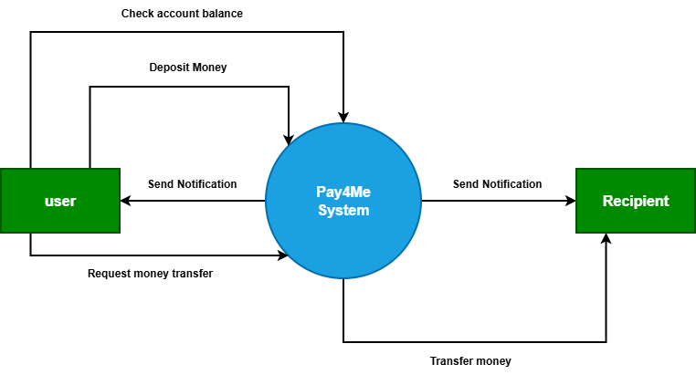
The context diagram for the Pay4Me System represents the system as a single high-level process that interacts with external entities, namely the User and the Recipient. It illustrates the flow of data between these entities and the system without showing internal processes.
The User is the primary actor who interacts directly with the Pay4Me System. The user can perform several operations, including checking account balance, depositing money, and initiating a request for money transfer. When the user requests to check their account balance, the system processes the request and returns the current balance information. In the case of a deposit, the user sends deposit details to the system, which updates the user’s account accordingly.
Additionally, the user can initiate a money transfer request by providing the recipient’s details and the amount to be transferred. The Pay4Me System processes this request and facilitates the transfer of funds to the intended recipient. After each successful transaction or activity, the system sends notifications to the user to confirm the status of the operation.
The Recipient is another external entity who receives funds from the system. Once a transfer request is successfully processed, the Pay4Me System transfers the specified amount to the recipient. The system also sends a notification to the recipient informing them of the received funds.
Overall, the context diagram highlights the Pay4Me System as the central processing unit that manages financial transactions and communication between the user and the recipient. It ensures secure handling of deposits, balance inquiries, and fund transfers, while also providing real-time notifications to both parties involved in the transaction.

2.2.1.2 Use Case Diagram of Pay4Me

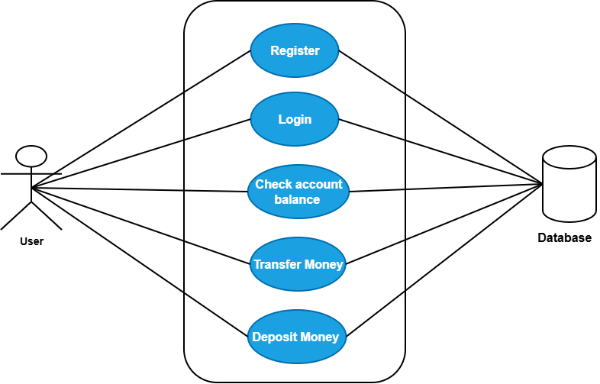
The use case diagram for the Pay4Me System shows how the User interacts with the system to perform key financial operations. The user is the main actor and can carry out activities such as registration, login, checking account balance, depositing money, and transferring money. These use cases represent the core functionalities of the system and define what the system is expected to do from the user’s perspective.
The Register use case allows a new user to create an account by providing the required details, which are stored in the system. After registration, the user performs the Login use case to gain access by verifying their credentials. Once authenticated, the user can check their account balance, deposit money into their account, or transfer money to another user. Each of these actions involves interaction with the system to process requests and return appropriate responses.
All the use cases are connected to a database, which serves as the central storage for user information and transaction records. The database ensures that user data is securely stored and accurately updated whenever a transaction occurs. It also supports the retrieval of information, such as account balances, making the system reliable and efficient in handling financial operations.

2.2.1.3 Sequence Diagram of Pay4Me

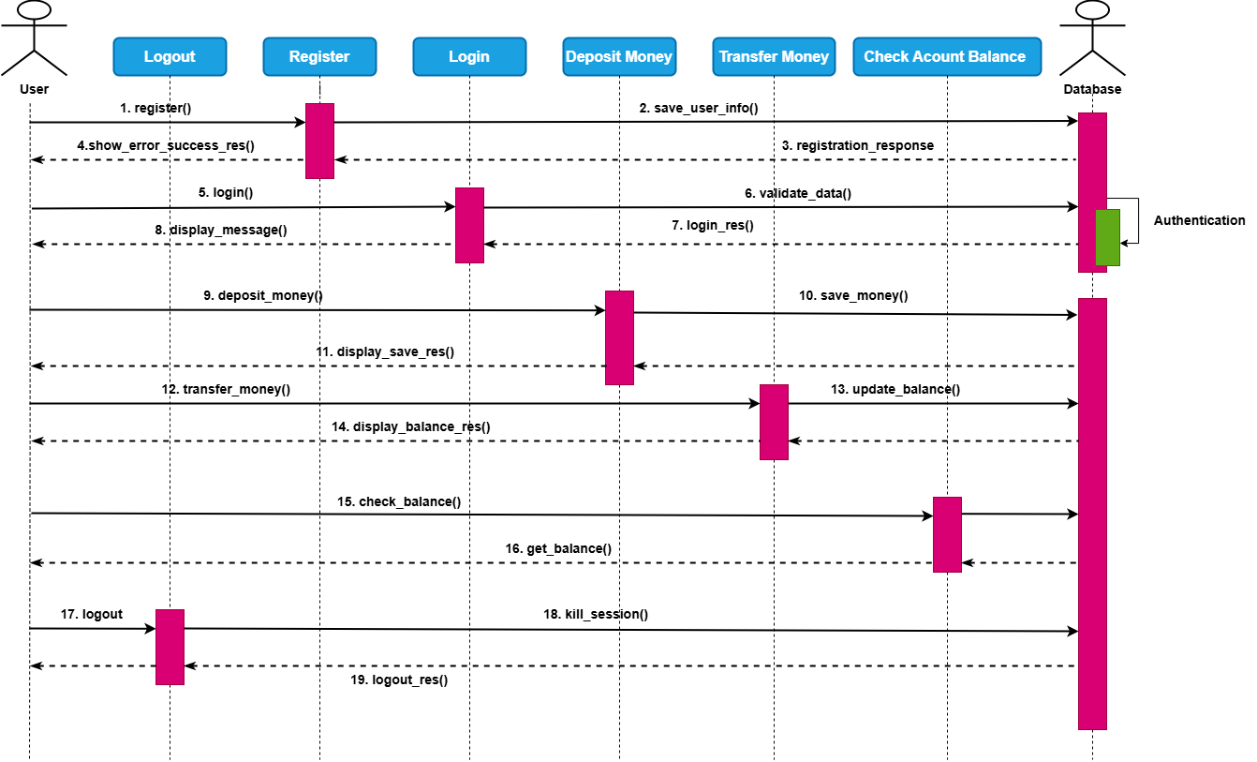

The sequence diagram for the Pay4Me System illustrates how the User, System, and Database interact over time to complete various operations. The process begins with the user performing the registration action by submitting their details to the system. The system processes the request and stores the user information in the database. After successful storage, a response is sent back to the user confirming that registration was completed successfully.
After registration, the user proceeds to login by providing valid credentials. The system validates the entered details by checking them against the data stored in the database. Once the credentials are verified, the system returns a login response granting access to the user. The user can then perform financial operations such as depositing money, where the system records the transaction in the database and updates the user’s balance before sending a confirmation response.
Furthermore, the user can initiate a money transfer, which the system processes by updating the necessary account records in the database and returning a transaction response. The user can also check account balance, which involves retrieving the current balance from the database and displaying it. Finally, the user can log out of the system, ending the session and completing the interaction sequence.

2.2.2. Features of the Pay4Me App
The Pay4Me application provides a wide range of features designed to support efficient and convenient financial transactions, particularly for international users. The system enables users to perform international payments for purposes such as tuition, fees, and visa applications, making it highly relevant for students studying abroad. It offers competitive exchange rates compared to traditional banking systems, thereby helping users reduce transaction costs. The application supports fast processing of payments, with some transactions confirmed instantly or within a short time frame. Additionally, the app is designed with ease of use in mind, featuring a user-friendly interface and a simplified payment process. It also supports multiple currencies, allowing users to transact across different countries without difficulty. Furthermore, the system provides specialized services such as SEVIS fee payments, examination fees, and credential evaluation services. Other features include multiple currency wallets, reward programs, and the ability to perform borderless transactions from any location worldwide.

2.2.3. Development Tools and Development Environment of the Pay4Me App
The development of the Pay4Me application involves the use of modern tools and technologies to ensure efficiency, scalability, and security. On the frontend, technologies such as React.js or Vue.js are used to create responsive and user-friendly interfaces, while backend development may utilize Node.js, Django, or Ruby on Rails to handle server-side operations. For mobile application development, cross-platform frameworks like Flutter or React Native are employed, alongside native technologies such as Swift for iOS and Kotlin or Java for Android. The system integrates payment gateways such as Stripe, PayPal, or WorldPay for secure transaction processing, and uses currency conversion APIs like Open Exchange Rates or XE API for real-time exchange rates. Security is enhanced through the use of OWASP standards and libraries. The database layer may include relational databases such as MySQL or PostgreSQL, as well as NoSQL solutions like MongoDB or Firebase. Cloud platforms such as AWS, Google Cloud, or Microsoft Azure are used for hosting and deployment, while version control is managed using Git with platforms like GitHub or GitLab. Testing tools such as Jest, Mocha, and Postman are used to ensure system reliability. The development environment includes IDEs like Visual Studio Code, Android Studio, and Xcode, along with collaboration tools such as Jira, Trello, Slack, or Microsoft Teams. Testing is further supported through the use of emulators and real mobile devices.

2.2.4. Review of The Good Features
The Pay4Me application offers several advantages that enhance its usability and effectiveness. One of its major strengths is the simplification of cross-border payments, allowing users, especially international students, to easily pay tuition, application fees, and other expenses abroad. The application provides competitive exchange rates, which help users save money compared to traditional banking methods. It also offers instant or near-instant payment confirmations, reducing uncertainty and improving user confidence. The inclusion of multiple currency wallets enables users to manage different currencies efficiently. Additionally, the system promotes transparency by providing clear instructions and notifications at each stage of the transaction process. Users can also access digital receipts, which simplifies record-keeping and documentation. Overall, the application streamlines the payment process and reduces the complexity associated with international financial transactions.

2.2.5 Review of The Bad Features
Despite its advantages, the Pay4Me application has some limitations and challenges. One of the key issues is the high cost associated with identity verification, which may arise due to strict regulatory requirements. This could potentially lead to compromises in compliance if not properly managed. Additionally, some users have reported delays in transaction processing, indicating that payments are not always completed within the expected time frame. Another concern is the possibility of encountering misleading or inaccurate information about the application and its services, which may affect user trust and decision-making. These limitations highlight areas that require improvement to enhance the overall reliability and effectiveness of the system.

2.2.6. Summary of The Pay4me App
The Pay4Me App is a user-friendly platform designed to simplify international payments, particularly for students managing tuition, visa fees, and other expenses abroad. The app offers competitive exchange rates, instant payment confirmations, multi-currency support, and services tailored to international students, such as SEVIS fee payments. Developed with a focus on security, it employs robust authentication measures and integrates seamlessly with payment gateways for efficient and reliable transactions.
While Pay4Me excels in ease of use and cost savings, some users report concerns with unsuccessful transactions, lengthy processing times, and challenges related to identity verification costs. Additionally, occasional instances of incorrect or misleading information have been noted. The app’s development leverages modern tools and frameworks such as React Native for cross platform mobile functionality, Laravel and Rust for backend robustness, MySQL for secure data storage, and cloud services like AWS for scalability and performance. Pay4Me stands out as an innovative solution for cross-border payments, though it has areas for improvement in reliability and user experience.

2.3. REVIEW OF THE EXISTING SYSTEM 2: UNSTRUCTURED SUPPLEMENTARY SERVICE DATA(USSD) OF KOFORIDUA TECHNICAL UNIVERSITY.

2.3.1. Overview of KTU USSD
The Unstructured Supplementary Service Data (USSD) is a communication protocol used by mobile phones to interact directly with a service provider’s computers. Unlike SMS, which sends a message to a server and waits for a reply, USSD establishes a real-time, session-based connection, making it faster and more interactive.
The Koforidua Technical University’s USSD *776*123#, a system used by the students to pay school related fees such as Tuition fee, entrance exams, transcript, industrial attachments (internships), medicals, hostels, re-sit, attestation and graduation, is the only digital fee payment system on campus. Students dial a specific USSD code (*776*123#) and follow a series of menu prompts to complete transactions. This system is advantageous because it works on any mobile device, does not require internet access, and is generally reliable in areas with limited connectivity. However, it can be tedious, error-prone, and lacks the user-friendly experience expected in modern digital transactions and finally it doesn’t provide future proof of payment when phone or confirmation message is erased.

2.3.1.1. Context diagram for KTU USSD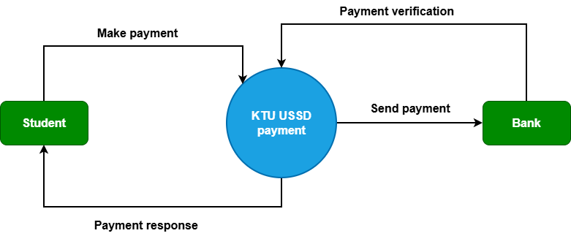

The context diagram for the USSD-based payment system of Koforidua Technical University illustrates how the system interacts with two main external entities: the Student and the Bank. The system acts as a central platform that facilitates communication and transaction processing between these entities.
The student initiates the interaction by making payment requests through the USSD platform. This involves entering payment details such as the required fees and confirming the transaction. Once the request is submitted, the system processes the information and forwards the payment details to the bank for further action. After processing, the system sends a payment response back to the student, informing them whether the transaction was successful or not.
The Bank plays a critical role in verifying and processing payments. The system sends payment requests to the bank, which then validates the transaction, confirms the availability of funds, and completes the payment process. After verification, the bank sends a response back to the system, which is then communicated to the student. Overall, the context diagram highlights the system as an intermediary that ensures secure and efficient payment processing between the student and the bank.

2.3.1.2. Use case diagram for KTU USSD

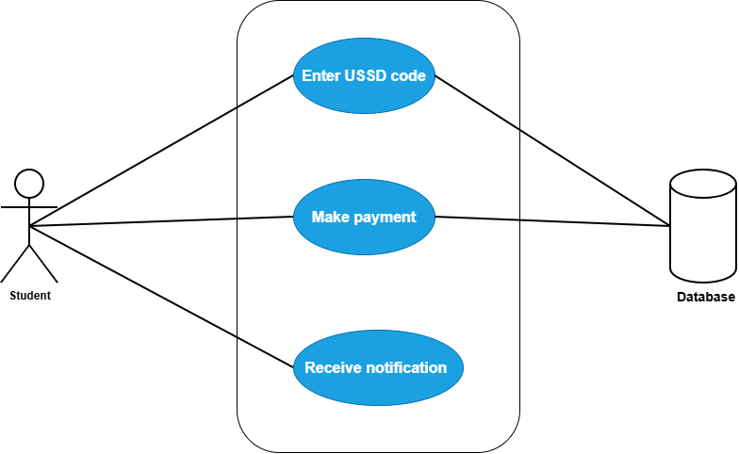
The use case diagram for the USSD-based payment system of Koforidua Technical University illustrates how the student interacts with the system to perform payment-related activities. The student is the primary actor and initiates the process by dialing the USSD code, which provides access to the payment platform. This action allows the student to interact with the system without requiring internet connectivity, making it convenient and accessible.
After successfully accessing the system, the student proceeds to make payment by entering the required details and confirming the transaction. Both the USSD code interaction and the payment request are processed and stored in the database, which maintains records of all transactions and user activities. The database ensures that payment information is securely stored and can be retrieved when needed.
Once the transaction is completed, the system sends a notification to the student indicating the status of the payment. This notification may confirm whether the payment was successful or unsuccessful. Overall, the use case diagram highlights the interaction between the student and the system, as well as the role of the database in supporting secure and efficient payment processing.

2.3.1.3. Sequence diagram for KTU USSD

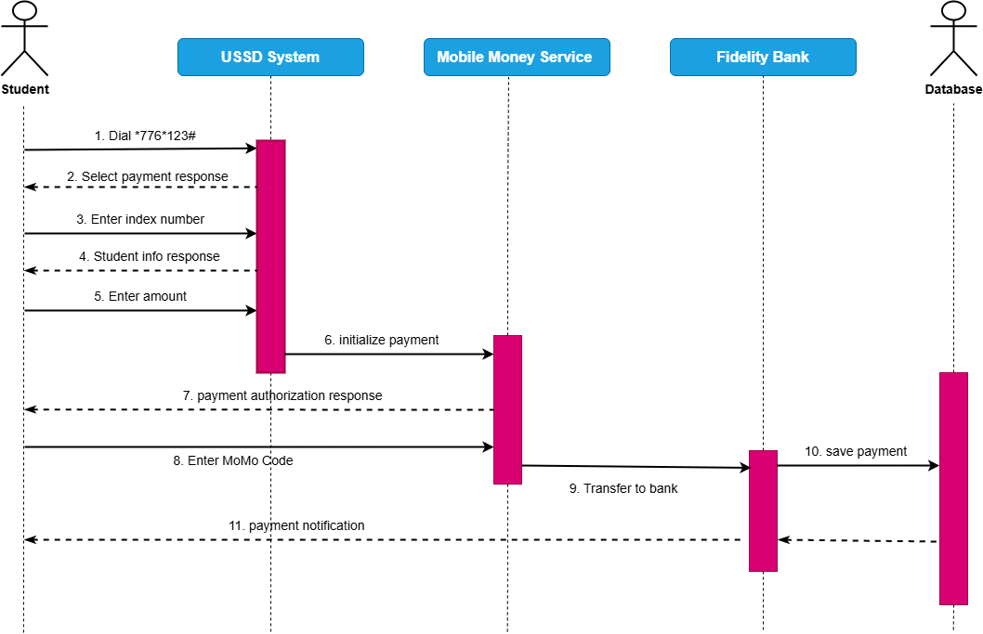
The sequence diagram for the USSD-based payment system of Koforidua Technical University illustrates the interaction between the Student, USSD System, Mobile Money Service, Bank, and Database. The process begins when the student dials the USSD short code to access the payment platform. The USSD system responds by displaying payment options, after which the student enters their index number. The system then retrieves and returns the student’s information as a response for confirmation.
After confirming their details, the student proceeds to enter the payment amount. The USSD system processes this request and sends a payment initialization message to the mobile money service. In response, the mobile money service sends an authorization prompt to the student, requesting confirmation of the transaction.
The student then enters their mobile money PIN to authorize the payment. Once authorized, the mobile money service transfers the funds to the bank. The bank processes the transaction and stores the payment details in the database. Finally, the database triggers a payment notification, which is sent back to the student to confirm that the transaction has been successfully completed.

2.3.2. Features of the KTU Payment Shortcode (USSD)
The Koforidua Technical University (KTU) payment shortcode system operates using Unstructured Supplementary Service Data (USSD) technology, which allows users to perform transactions without requiring internet connectivity. This makes the system highly suitable for areas with limited or no access to mobile data or Wi-Fi. The system provides a menu-driven interface where users navigate through structured options to complete transactions, such as selecting payment options, entering student identification numbers, and specifying payment amounts. Additionally, the system is device and platform independent, meaning it can be accessed on any type of mobile phone, including both feature phones and smartphones, without the need to install any application. Access to the system is initiated through short codes, which are easy to dial and provide quick entry into the service. The USSD system also operates in a session-based mode, ensuring that interactions remain active until the transaction is completed or times out, thereby providing a basic level of security. Furthermore, the system is cost-effective, as it is often free or requires minimal charges, making it accessible to a wide range of users.

2.3.3. Development Tools and Development Environment of the System
The development of the USSD payment system utilizes a set of tools and technologies designed to ensure efficiency and reliability. The backend of the system is developed using Hypertext Preprocessor (PHP), which is well-suited for handling server-side logic and processing user requests. PostgreSQL is used as the database management system to store user data, transaction records, and session information due to its robustness and reliability. The system integrates with a payment gateway, specifically the Paystack API, to facilitate secure processing of payments through mobile money services and banking systems. In terms of the development environment, Visual Studio Code is used as the primary code editor for writing and testing backend code due to its flexibility and support for multiple programming languages. XAMPP is employed as a local server environment to simulate real server operations during development and testing. Additionally, PostgreSQL is used consistently in both development and production environments to ensure uniformity and data integrity.

2.3.4. Review of the Good Features of USSD
The USSD system offers several advantages that contribute to its effectiveness in facilitating payments. One of its major strengths is its ability to function offline, allowing users to access services without requiring mobile data or internet connectivity. This makes it highly accessible to students regardless of their technological resources. The system is also device-independent, enabling it to work seamlessly across different types of mobile phones, from basic feature phones to advanced smartphones. Another key advantage is real-time interaction, as USSD provides immediate responses during transactions, ensuring quick feedback and confirmation. Additionally, the system is cost-effective, as transactions are either free or charged at very minimal rates, making it affordable for users, particularly those in low-income or rural areas. The simple menu-based interface further enhances usability, as it is easy to understand and navigate, especially for users familiar with basic mobile operations.

2.3.5. Review of the Bad Features of USSD
Despite its advantages, the USSD system has several limitations that affect its overall efficiency and user experience. One major drawback is the issue of session timeouts, where transactions may be interrupted if the user takes too long to respond, typically within a short time frame such as 90 seconds. The system also has a limited user interface, as it is restricted to text-based menus without graphical elements, making it less interactive and less user-friendly compared to mobile applications. Furthermore, USSD systems often lack detailed feedback and error handling mechanisms, meaning that users may receive generic error messages without clear guidance on how to resolve issues. Security is another concern, as USSD does not provide advanced encryption or robust security protocols, making it more vulnerable to potential risks compared to modern app-based systems. Lastly, the system is not easily scalable or flexible, as adding new features such as transaction history, digital receipts, or enhanced user guidance is difficult due to the inherent limitations of the USSD platform.

2.3.6 SUMMARY OF THE SYSTEM REVIEW
The Koforidua Technical University (KTU) mobile money short code system, accessed via *776*123#, is a USSD-based platform that enables students to pay for school related fees such as tuition, transcripts, and hostel charges. It utilizes the USSD communication protocol, which allows mobile users to interact with backend servers through real-time, session-based exchanges without needing internet access. This makes the system highly accessible, particularly in areas with poor network coverage or for users with basic mobile phones. One of the key advantages of the KTU USSD system is its simplicity and inclusivity. It supports all mobile devices and requires no app installation, making it ideal for users across different economic backgrounds.
The platform also offers a structured, menu-driven user interface and provides fast responses due to its session-based design. Furthermore, the system is cost-effective for students, with minimal charges for transactions, and offers a secure, though basic, session structure to protect user data. Despite these strengths, the system has several notable limitations. The short timeout window often disrupts transactions mid-session, especially when users take time to gather required information. The user interface is text-only and lacks intuitive features such as visual progress indicators or confirmation screens. Additionally, it does not provide permanent proof of payment, as 28 confirmation relies solely on SMS messages, which can be deleted or lost, leaving no transaction history for future reference.
From a technical standpoint, the system was developed using PHP (Laravel) and PostgreSQL, with tools like Visual Studio Code and XAMPP used in the development environment. Payment integrations were handled via APIs and services like Pay stack. While functional, the USSD system's rigid structure and limited scalability highlight the need for more modern solutions. A mobile application like Student pay could revolutionize the current system by offering enhanced usability, better security, permanent transaction history, and a more user-friendly interface.

2.4 REVIEW OF THE EXISTING SYSTEM 3: SCHOOLPAY

2.4.1. Overview of SchoolPay App
SchoolPay Enterprise Resource planning (ERP) is an innovative comprehensive student information management system and school fees payment system for schools and universities that gives school owners and management a real-time transaction view of payments and enables the seamless management of all other aspects of their institutions. SchoolPay is an integrated educational payments and school administration platform built by Service Cops (Fin-com Technologies), operational since 2016. According to AllAfrica (2023), SchoolPay can be used by educational institutions, at all levels; from daycare centers, all the way to universities in rural and urban settings.
SchoolPay can be used by educational institutions at all levels, from daycare centers, all the way to universities in both Rural and Urban Settings. Much more than just paying school fees, digital resources for improving the delivery of education services. Over the past decade, SchoolPay has continuously evolved to simplify the lives of millions of parents, students and schools across the African continent as an expression of our commitment to improving lives and universal financial inclusion. The system enables parents, students, and school administrators to manage school-related payments efficiently, reducing manual efforts and improving accuracy in tracking transactions.

2.4.1.1. Context diagram for SchoolPay

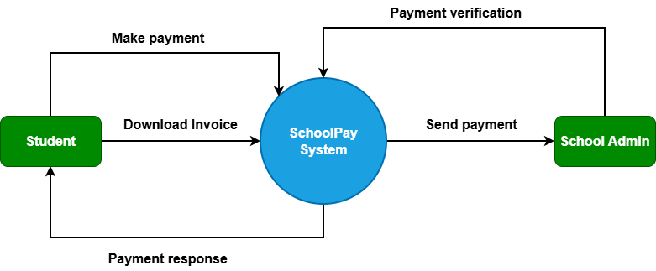
The context diagram for the SchoolPay System illustrates the interaction between the system and two main external entities: the Student and the School Administrator. The system acts as the central platform that processes payments and manages communication between these entities.
The student interacts with the system by initiating payment transactions. The student can make payments through the system, after which the system processes the request and generates a response indicating whether the payment was successful or not. In addition, the student can download an invoice as proof of payment, which is generated and provided by the system. These interactions ensure that students can complete their financial obligations and obtain necessary documentation.
The School Administrator interacts with the system by verifying payments made by students. The system sends payment details and records to the administrator for confirmation and validation. This ensures that all transactions are properly checked and recorded. Overall, the context diagram highlights the SchoolPay System as an intermediary that facilitates secure payment processing, provides feedback to students, and supports administrative verification of transactions.

C2.4.1.2. Use Case diagram for SchoolPay

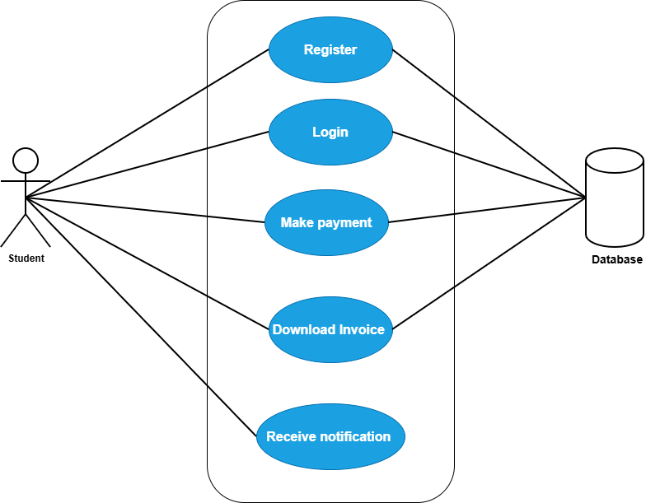
The use case diagram for the SchoolPay System illustrates how the student interacts with the system to perform key activities related to fee payment. The student is the primary actor and can carry out operations such as registration, login, making payments, downloading invoices, and receiving notifications. These use cases represent the main functionalities of the system and define how the student engages with the platform.
The Register use case allows a new student to create an account by providing the required details, which are stored in the system. After registration, the student performs the Login use case to gain access by verifying their credentials. Once authenticated, the student can make payment, which involves submitting payment details and completing the transaction. The student can also download an invoice as proof of payment. All these actions registration, login, payment processing, and invoice generation are connected to the database, where user data and transaction records are securely stored and managed.
Additionally, the system provides a notification feature that informs the student about the status of their activities, such as successful registration, login, or payment confirmation. This ensures that the user is kept updated at every stage of interaction. Overall, the use case diagram highlights the relationship between the student and the system, as well as the role of the database in ensuring efficient and reliable operation.

2.4.1.3. Sequence diagram for SchoolPay

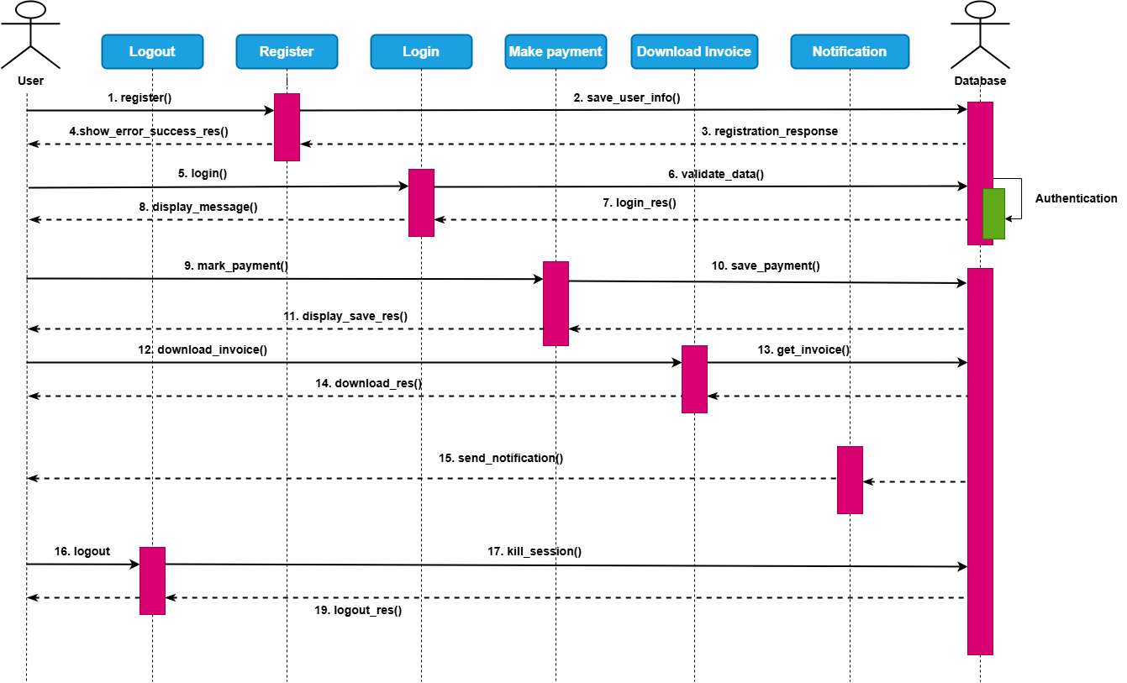
The sequence diagram for the SchoolPay System illustrates the interaction between the Student, System, and Database over time. The process begins when the student initiates registration by submitting their details to the system. The system processes the request and stores the information in the database. Once the data is successfully saved, the system sends a registration response back to the student confirming that the account has been created.
After registration, the student proceeds to login by entering valid credentials. The system verifies these credentials by checking them against the data stored in the database. Upon successful validation, the system grants access and returns a login response. The student can then make payment, where the system processes the transaction, stores the payment details in the database, and updates the necessary records accordingly.
Following a successful transaction, the student can download an invoice, which is generated from the stored payment data in the database. The system also sends a notification to inform the student about the status of the payment and other activities. This sequence of interactions ensures that all operations are properly processed, recorded, and communicated to the user in a clear and efficient manner.

2.4.2. Features of the System
The SchoolPay system provides several features designed to enhance the efficiency and accuracy of school fee payments. One of its key features is the use of unique student payment codes, where each student is assigned an individual identification code linked to their school account. This ensures that all payments are accurately credited and tracked in real time, thereby reducing errors in the payment process. The system also offers a secure payment portal that facilitates safe online transactions for various school-related payments, including tuition and event fees. In addition, the platform supports multiple payment channels such as mobile money services (MTN and AirtelTigo), M-sente, and bank transfers, providing flexibility and convenience for users. The inclusion of dashboards and reporting tools enables real-time monitoring of payments, generation of management information systems (MIS) reports, defaulter lists, and financial analytics. Furthermore, the system helps save time and cost by eliminating the need for physical queues and reducing risks associated with cash handling and fraud.

2.4.4. Development Tools and Development Environment of the System
The development of the SchoolPay system utilizes modern tools and technologies to ensure performance, scalability, and maintainability. On the frontend, React Native is used to develop a cross-platform mobile application, allowing the system to run efficiently on both Android and iOS devices. The backend is developed using Node.js, which handles server-side logic and ensures smooth processing of user requests. MySQL is used as the database management system for storing and retrieving user data and transaction records. The development environment includes tools such as Visual Studio Code for coding, Docker for containerization and environment consistency, and Git for version control and collaboration. Additionally, the system integrates various payment gateways, including mobile money services, bank transfers, and local financial APIs, to facilitate secure and reliable payment processing.

2.4.5. Review of the Good Features
The SchoolPay system demonstrates several strengths that enhance its usability and effectiveness. One of its major advantages is its user-focused design, which provides an intuitive interface that minimizes the learning curve for new users. The system also incorporates strong security measures, including robust encryption, to ensure safe and reliable financial transactions. Another key benefit is the provision of real-time updates, where users receive instant notifications regarding their transactions, improving transparency and user confidence. Furthermore, the system supports multiple payment options, increasing accessibility for users with different preferences. The platform is also customizable, allowing schools to tailor the system according to their branding and specific operational requirements.

2.4.6. Review of the Bad Features
Despite its advantages, the SchoolPay system has some limitations that may affect its performance and user experience. One major drawback is its dependency on internet connectivity, as full system functionality requires a stable network, which may be a challenge in areas with poor connectivity. Additionally, limited or slow technical support can hinder the timely resolution of user issues. The initial setup process for schools may also be complex, requiring significant time and technical expertise to implement effectively. Furthermore, scalability issues may arise as the number of users increases, potentially affecting system performance. Lastly, the system relies heavily on external APIs for payment processing, meaning that any disruptions or failures in these third-party services can negatively impact system operations.

2.4.7. SUMMARY OF SCHOOLPAY APP
SchoolPay, developed by Service Cops (Fin-com Technologies) in 2016, is a comprehensive educational payment and school administration platform that has revolutionized School Payment systems across East and Southern Africa. Serving over 10,000 institutions and 6 million+ students, the system is designed to simplify and secure financial transactions while promoting universal financial inclusion. Key features include unique student payment codes for accurate and real-time tracking, a secure payment portal for tuition and fee payments, and multiple payment channels, including mobile money and bank transfers. Additionally, the platform offers real-time dashboards and reporting tools for analytics, financial tracking, and improved efficiency, saving time and minimizing risks such as cash mismanagement and forgery.
The system's development leverages advanced tools, including React Native for cross-platform development, Node.js for backend logic, and MySQL for database management. The environment is supported by Visual Studio Code, Docker, Git, and integrations with local financial APIs. While SchoolPay boasts an intuitive user-focused design, robust security, instant notifications, and customizable options, it faces challenges such as dependence on stable internet connectivity, limited technical support, complex initial setup, scalability concerns, and reliance on third-party APIs. Overall, SchoolPay remains a transformative solution for School payment management, with potential for further enhancements to address its current limitation

